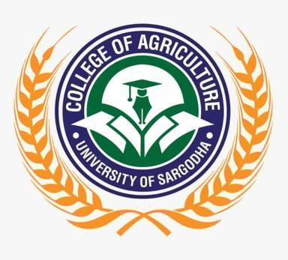  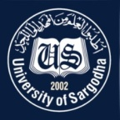 | Faculty Positions on Visiting Basis
College of Agriculture
University of Sargodha
Applications for the following positions are invited from Pakistani nationals for Fall Semester-2022.
Teaching Faculty

Sr.# | Positions | Lecturer | A.P | Eligibility Criteria | Nature of Post
01. | Animal Sciences | 01 | 01 | Lecturer: Specialized- Poultry Production / Sciences  A.P: Specialization-Livestock Management | Visiting Faculty  (Open merit, for Fall semester 2022).
02. | Forestry | Total 03: As per requirement |  | Ph.D in relevant field for AP,  M.Sc. (Hons.) / M.Phil / MS in relevant field for Lecturer
03. | Agricultural Economics | Total 03: As per requirement
04. | Entomology | 01 | 02
05. | Plant Pathology | Total 01: As per requirement
06. | Soil & Environmental Sciences | As per requirement
NOTE |  | General Information
- As per university policy, the institute/department reserves the right not to consider any application or fill any post without giving any reason.
- Candidates are required to submit complete C.V and attested copies of testimonials along with
duly filled application form in the concerned office.
- Prescribed application form may be downloaded from university website
(https://www.uos.edu.pk/adminForms)
- Applications complete in all respects should reach in the College on or before 13-09-2022 (04:00 PM).
- Interview of the short-listed candidates will be conducted on 19-09-2022 (at 11:00 AM) in the office of Principal, College of Agriculture, University of Sargodha.
- Only short-listed candidates will be called for interview.
- The applicants having provisional transcript will not be eligible for the visiting faculty
- Applications received after due date will not be entertained.
- Candidates with relevant experience will be preferred.
- Seats can be increased or decreased according to the requirement of department.
- Applications address to Concerned Departmental Chairperson / Incharge, College of Agriculture, University of Sargodha.
- Online applications will not be accepted.

Prof. Dr. Muhammad Ather Nadeem
Principal
College of Agriculture
University of Sargodha

